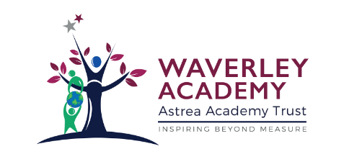

Waverley Academy

Astrea Core Values Strategy

2020-21
Context
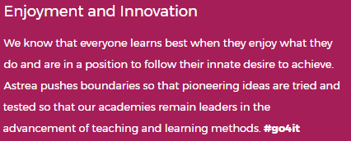
Waverley Academy is a proud member of the Astrea Academy Trust. Committed to the notion of Inspiring Beyond Measure, Astrea is built upon the concept of five Value Partners:
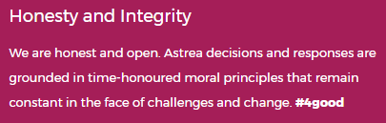
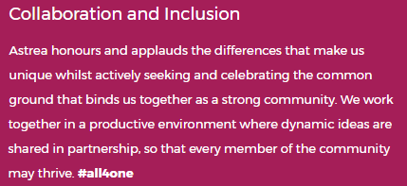
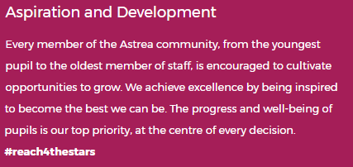
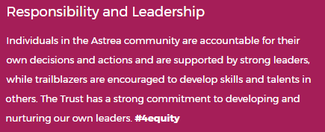

At Waverley Academy, we believe it is our responsibility to teach in a way that meets the expectations of our Value Partners in our journey to Inspiring Beyond Measure. For our children, this translates to our five Core Values: Resilience; Empathy; Aspiration; Contribution; Happiness.
Rationale
Our Value Partners provide the basis for our vision and values at Waverley Academy. We serve around 240 children aged between 3 and 11 years and we are determined to communicate our Core Values in terms that are accessible to our entire school community. Our Core Values Strategy 2020-2021 outlines how we will deliver our vision of Inspiring Beyond Measure for our learners and families in the year ahead and beyond. At Waverely Academy, we believe that Learning is the Key and as an academy family, we can rise with challenges to excel in the 21st Century.

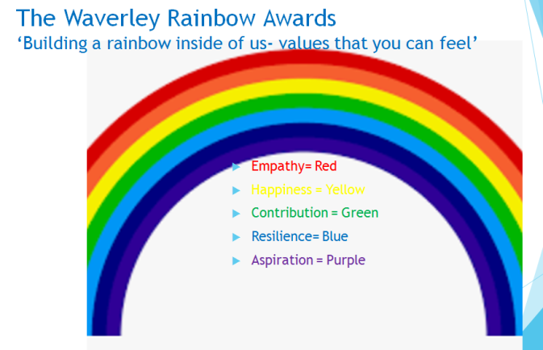
Strategy
Each Core Value is linked to a rainbow colour. Each colour will come to symbolise and embody its Core Value. Our Rewards Strategy and Ethos will both be securely linked to the Waverley Rainbow Awards. In lessons, colleagues will explicitly link learning to Waverley Rainbow, building up an emotional literacy rainbow for each child. This concept is outlined below.
Resilience |  | - Working hard and overcoming setbacks  - Working over a longer period to reach a goal  - Learning from our experiences  - Keeping going
Empathy |  | - When we show our peers that we care, that we understand how they feel and that we can help  - Working together to a shared goal  - Pooling resources so that we all benefit equally  - Communicating
Aspiration |  | - Presenting what we have learned or done  - Explaining ourselves  - Sharing our work with others within and outside our academy  - Understanding the bigger picture  - Leading
Contribution |  | - Playing our part  - Doing the right thing, even when no-one is looking  - Being part of a team  - Supporting others  - Trying our best  - Leading a team
Happiness |  | - Sharing our thoughts with others  - Showing that we enjoy what we do  - Rewarding each other  - Having personal goals  - Reaching a target  - Improving and getting better at something – making progress

Rewards
Teachers will distribute token points for each of the Core Values – for example where a child demonstrates leadership skills in learning, they will receive a aspiration Token, where a child supports one of their peers, perhaps on the playground, they will be awarded a empathy Token. The tokens will be collected in central containers, located in each classroom. Each week, school council will weight that week’s tokens and report back on which of the Core Values we have exhibited most in school, this will be reported in our weekly Rainbow Awards assembly, where what we have done well will be celebrated and what our focus should be will be explained for the week ahead.
Waverley Rainbow Awards Assembly
As well as reporting back on that week’s Core Values, the Waverley Rainbow Awards assembly will be an opportunity for each teacher to select two children to receive a specific mention and postcard, which will be awarded based on one of the Rainbow Awards, linked directly to Core Values. For example, a child who has improved the quality of their writing may receive a specific mention for happiness, their parents will be invited to the Waverley Rainbow awards assembly and the child will receive a post card. Any child receiving a specific mention in the weekly Rainbow Assembly awards will enter a termly draw for a Waverley core value pin.
Class Dojo
Dojo messages will always be linked directly to Rainbow Core Value award.
Twitter
We will regularly tweet our success and these will always be linked with the Waverely Rainbow Awards.
Communication
Who | How | When
Children | Launch Assembly  In class discussion + regular reminders – ‘Hillside Shoe Review’ | w/c 31st August- First week back
Parents | Leaflet | w/c 7th September
Staff | Staff Meeting/ Inset day  This Strategy Document | w/c 31st August

Review
The strategy will be reviewed on an on-going basis. Bespoke Parent, Pupil and Staff surveys will be used to gather stakeholder voice.

