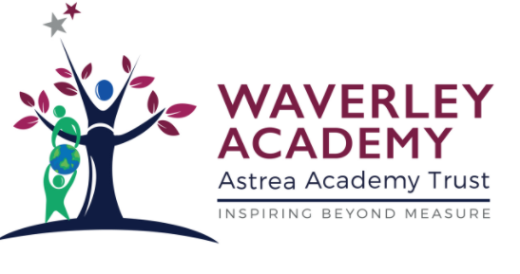

Waverley Primary Acceptable Use of Remote Learning Agreement
Please complete and return to school.
Childs Name:
Class:
Date of Birth:
Parents and Child,
Please read through/discuss the statement outlined below:

I understand that the school takes every reasonable precaution to keep pupils safe and to prevent pupils from accessing inappropriate materials, including behaviour policies and agreements, physical and technical monitoring, education and support and web filtering. However, the school cannot be held responsible for the nature and content of materials accessed through the internet and mobile technologies, which can sometimes be upsetting.

I understand that internet and device use in school, and use of school-owned devices, networks and cloud platforms out of school may be subject to filtering and monitoring. These should be used in the same manner as when in school.

I understand that whilst home networks are much less secure than school ones, I can apply child safety settings to my home internet. Internet Matters provides guides to help parents do this easily for all the main internet service providers in the UK.

If I see, watch, read, hear or receive anything I am unhappy with online or I receive a message from anyone online that makes me feel uncomfortable, e.g. bullying, sexual, extremist / hateful content, I will not respond to it but I will talk to a trusted adult about it.

I know who my trusted adults in school and at home are - if I am unsure, and have a concern or a worry, I can contact the Safeguarding Lead at my school on [Safeguarding@astreawaverley.org], or I can access support through Childline, The Mix, or The Samaritans.

When accessing online lessons, I will follow the rules set out by the teacher which include: How and when to ask a question and how and when to use the video camera.

I will not record any live learning sessions. All sessions delivered through TEAMS will be recorded by the teacher in order to share with pupils who were unable to attend the session and to document the session content.

The questions I ask within lessons, or information I upload, will always be polite and sensible. I understand that all communication I send reflect on me and the school. Whilst participating in live lessons, I will behave in accordance with the school policy, remembering to be polite, sensible and appropriate. I am aware that failing to do so may result in not being able to participate in live sessions in the future.

Continued overleaf

Parental Consent (Please tick to accept)
I have read and understood and agree for my child to take part in online learning and agree they will comply with the Acceptable Use of Distance Learning as outlined in the statements above

Child Consent (Please tick to accept)
I have read, discussed with my parent and understood and agree to comply with the Acceptable Use of Distance Learning as outlined in the statements above

