14th April 2021
Dear Year 6 Parents/Carers,

We know that the final term of your child’s primary school journey can be emotional and scary. The current COVID-19 pandemic means that the carefully managed transition between primary and secondary school will look different for children this year, and we are aware this may be causing anxieties for both you and your child.
As you know we are working hard to get our Year 6 pupils back into school ahead of the Summer holidays, and this remains a priority for us. However, we do want to make sure we have plans in place that will support all pupils whether they do return to school or not.
I wanted to reassure you that we are working hard with our colleagues in the relevant high schools, and with Doncaster Council, to make sure we have a robust plan for a smooth and supportive transition from Year 6 to Year 7.
These plans include: virtual visits to high schools; information packs for both children and parents; and dedicated sessions that can be done from home or in school. This will ensure all children have access to the tools they would have been given, had the Pandemic not have been an issue. Unfortunately, due to the current situation, there are no plans for children to attend their new secondary school in person for transition days. For the time being, the range of transition activities we have planned will take place virtually.
Over the coming weeks you will receive more details from your child’s secondary school and the transitions team at Doncaster Council.
As always, if you have any specific questions or concerns in the meantime, then please contact us the school office.

Yours Sincerely,
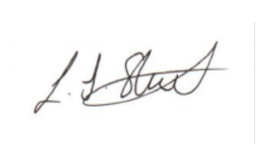

Louise Stanton
Principal

