Mathematics Policy

Policy Adopted: 4th January 2022
Review: 05 September 2022

Waverley Ethos
At Waverley Academy, children come first and our priority is to deliver high quality teaching and learning whilst at the same time providing rich and truly enjoyable learning experiences for our community of children. Everything we do as a school is to ensure that the children achieve their very best, and that they are socially and emotionally ready for academic success. We are deeply aware that children only get one chance at their primary education and it is our job to ensure that they all reach for the highest levels of personal achievement and development.
The vision of the curriculum at Waverley Academy is to give all pupils the knowledge and skills they need to succeed in life. The Waverley Curriculum ethos aims to create a thirst for learning, through first hand experiences and stimulating hooks, that broaden horizons and pushes expected boundaries. Children will leave Waverley Academy successful, with a love of learning that remains with them for their next phase in education.
Waverley Academy aims to provide a curriculum that is broad, balanced, relevant and differentiated to provide for varied abilities. Barriers to learning are removed and we provide suitable learning challenges that respond to diverse needs. This encompasses a variety of exciting, first-hand experiences to enable children to acquire appropriate skills, knowledge and understanding preparing them for today’s world. Through the provision of a stimulating environment, children will develop to their full potential academically, socially and physically.
Purpose
This Policy aims to define the ways in which the Academy will ensure high quality teaching, learning and assessment for all children in mathematics. It outlines the key practices in place at the Academy and how these are intended to impact on the progress, attainment and wellbeing of all children.

Policy Objectives.
This policy aims to liberate teachers from unnecessary workload and from a focus on any activity which has low impact in the classroom. It is the express intention that this policy will support the Academy to recruit and retain excellent teachers through a sensible and appropriate approach to workload and through their elevated status as a result of a policy which allows teachers to lead their students’ learning in a direct and effective manner. The benefits to students are clear and are fundamentally outlined throughout the policy.

Policy Scope
This policy applies to all teaching staff within the academy. It is the responsibility of all individuals in the academy to familiarise themselves with this policy and comply with its provisions.

Training and awareness
The academy will ensure that all individuals understand their responsibilities under this Policy by providing appropriate training, education and guidance. The level of training and the nature of the education and guidance may vary depending upon the role as relevant to the policy.

Reporting and Non-Compliance
The impact of this policy will be measured and managed through quality assurance and ultimately through performance management, as engagement with training and development is a cornerstone of performance management targets.

Statement of Intent
The intent of our Mathematics curriculum is to deliver a curriculum which is accessible to all and that will maximise the outcomes for every child so that they know more, remember more and understand more.
Our overarching aims in order to do this are:
- To use “The Dimensions of Depth” to develop a deep understanding in mathematics.
The Dimensions of Depth are:
- 1. Conceptual understanding
- 2. Language and communication
- 3. Mathematical thinking

- To enable all pupils to have a meaningful understanding of the maths they are learning, by representing it in different ways.
- To enable all pupils to use mathematical language to communicate related ideas and think mathematically with the concept.
- To enable all pupils to apply their understanding to a new problem in an unfamiliar situation.
- To develop a love of quick recall multiplication tables throughout the whole school.
- To be able to confidently use the four operations effectively by the end of LKS2.
- To provide pupils with a “toolkit” to use throughout lessons to support understanding and answering of a given problem.
- To provide a chance for all pupils to feel successful in a mathematics lesson.
- To develop a strength in presentation; producing well laid out, clear operations and solutions.

Teaching and Learning at Waverley

Rosenshine’s Principals of Instruction

The Academy supports the ideas laid out in Barak Rosenshine’s paper, Principles of Instruction: Research Based Strategies That All Teachers Should Know. Since learning is something that we cannot, in any material sense, see, we need to take note of the evidence we have at our disposal. In Principles of Instruction, Rosenshine has provided us with a series of strategies that, implemented consistently allow us to make to improve pupil learning.

Rosenshine’s Principles draws research from three key sources:
1. Research in cognitive science
2. Research on the classroom practices of master teachers
3. Research on cognitive supports to help pupils learn complex tasks.

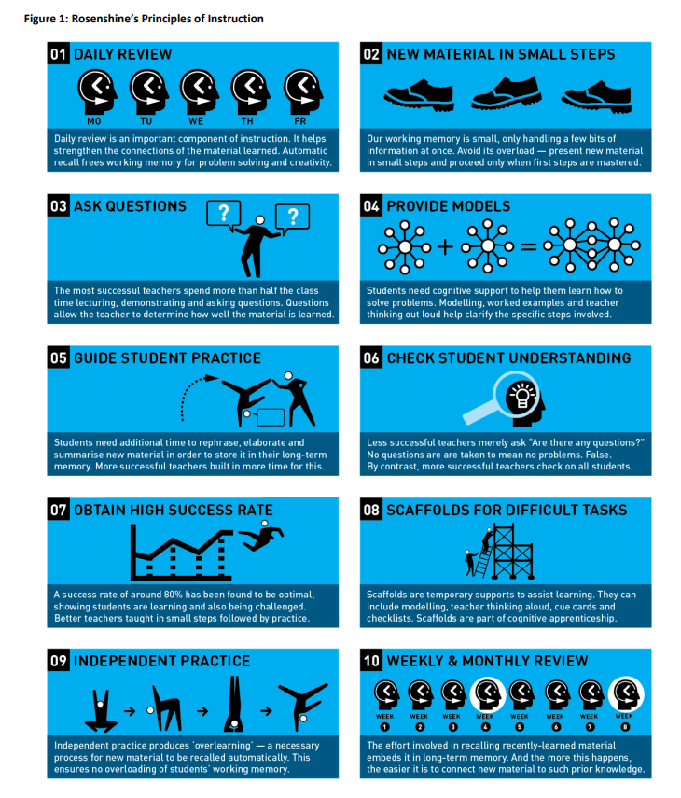

Inclusion
All teaching and learning is personalised according to need. This may include the use of additional resources, the provision of some adult support, additional intervention or other scaffolding. This is planned by class teachers on a lesson-by-lesson basis and can be identified in teacher planning.

Mathematics at Waverley

This policy contains the key pencil and paper procedures that will be taught within our school. It has been written to ensure consistency and progression throughout the school and reflects a whole school agreement. At Waverley we promote the linking of skills to ensure that tasks have context and calculations are part of real life situations, are meaningful and learning is engaging and interesting.

Although the focus of the policy is on pencil and paper procedures it is important to recognise that the ability to calculate mentally lies at the heart of Mathematics. Mental methods for teaching mathematics will be taught systematically from Foundation Stage onwards and pupils will be given regular opportunities to develop the necessary skills. However mental calculation is not at the exclusion of written recording and should be seen as complementary to and not as separate from it.

In every written method there is an element of mental processing. Sharing written methods with the teacher encourages children to think about the mental strategies that underpin them and to develop new ideas. Therefore written recording both helps children to clarify their thinking and supports and extends the development of more fluent and sophisticated mental strategies.

During their time at this school children will be encouraged to see mathematics as both a written and spoken language. Teachers will support and guide children through the following important stages:
• Developing the use of pictures and a mixture of words and symbols to represent numerical activities;
• Using standard symbols and conventions;
• Use of jottings to aid a mental strategy;
• Use of pencil and paper procedures;

This policy concentrates on the introduction of standard symbols, the use of the empty number line as a jotting to aid mental calculation and on the introduction of pencil and paper procedures. It is important that children do not abandon jottings and mental methods once pencil and paper procedures are introduced. Therefore children will always be encouraged to look at a calculation/problem and then decide the best method to choose – pictures, mental calculation, with or without jottings. Our long-term aim is for children to be able to select an efficient method that is appropriate for a given task.

They will do this by always asking themselves:
• ‘Can I do this in my head?
• ‘Can I do this in my head using drawings or jottings?’
• ‘Do I need to use a pencil and paper procedure?’

Year group labels are not exclusive, higher attaining pupils will be challenged, accessing material which requires them to think deeper. Similarly pupils who are struggling will access less complex methods as appropriate.

* Our current policy states that we carry above when we are solving additions. As chn come through school we need to teach them to carry on the line. This links in with long multiplication.

Calculation across the school

EYFS
Addition and Subtraction.
Simple number rhymes, songs and stories are an essential element to introduce simple mathematical concepts and language in this area.
In EYFS children are encouraged to make collections of objects or ‘sets’. Children are encouraged to count objects carefully touching each object, saying one number name for each object.
Addition is introduced by adding one more to a group or collection then recounting to find the total. Subtraction is introduced by taking away one from a group or collection and recounting to find how many are left.
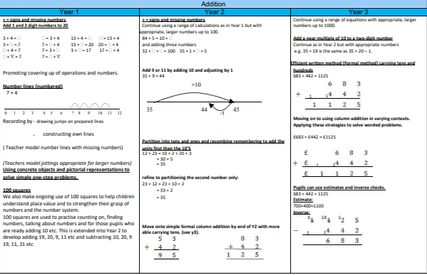
As children become more confident with this simple number lines are introduced to encourage counting on or back. Children are encouraged to jump along, move an object or finger on the number line, going forwards to count on and backwards to count back.
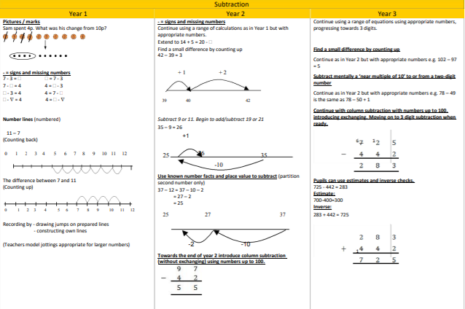
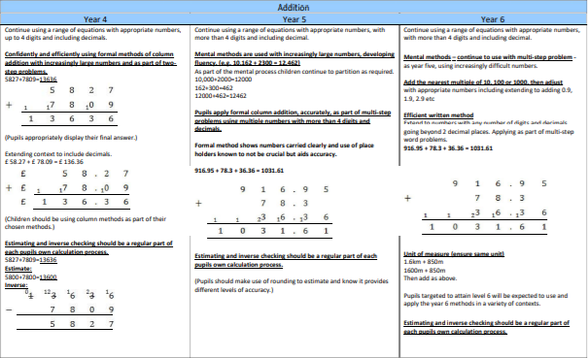
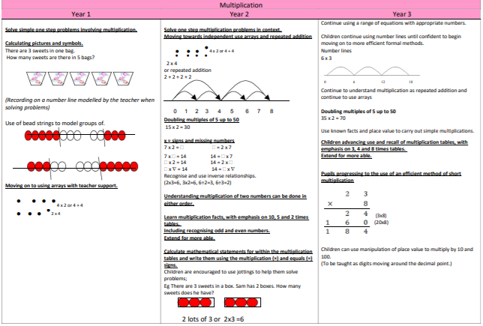
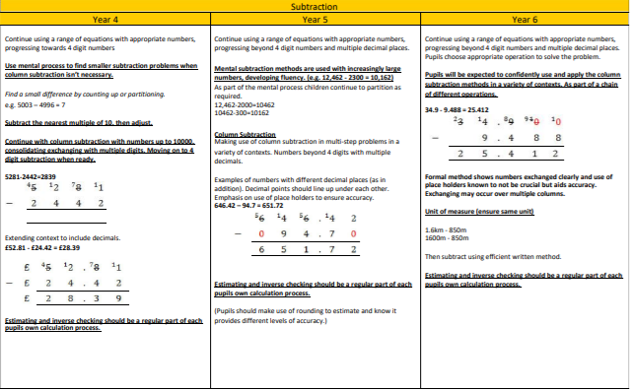
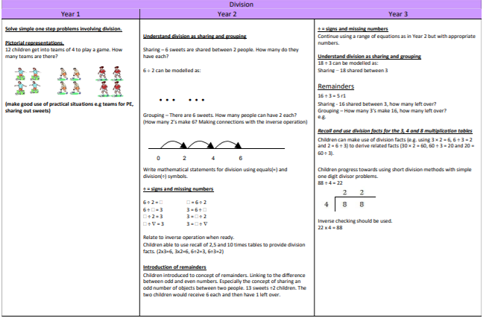
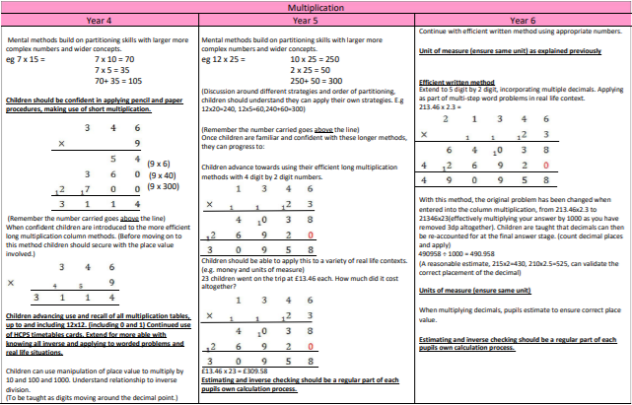
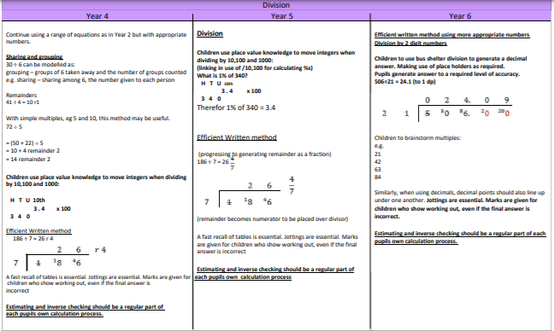
Minimum Expectations
Teachers plan lessons for each day of the school year. The Academy holds long term overviews, which can be found in the appendices. The following expectations are the minimum requirements of all children at Waverley.

Maths Meetings:
Maths Meetings are a vital part of the MM programme and are used to consolidate key learning outside of the maths lesson. Maths Meetings provide an opportunity to teach and revise ‘general knowledge maths’ which may not explicitly be covered during the maths lesson. This enables pupils to practise applying concepts and skills on a regular basis, meaning they are continually building on their mastery of these concepts.
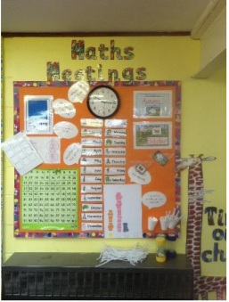
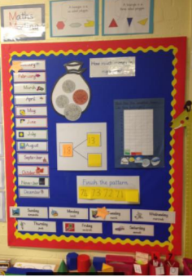
MM provides guidance on what should be covered in Maths Meetings on a half-termly basis. These suggestions complement the work covered to date from the Programme of Study, as well as preparing pupils for upcoming topics.
A Maths Meeting board is recommended around which to centre the meeting. There are several examples of what the board might look like available on the Toolkit.

Maths Lessons:
The Mathematics Mastery curriculum is cumulative - each school year begins with a focus on the concepts and skills that have the most connections, and this concept is then applied and connected throughout the school year to consolidate learning. This gives pupils the opportunity to ‘master maths’; by using previous learning throughout the school year, they can develop mathematical fluency and conceptual understanding.

The curriculum is designed to make sure that the requirements of the national curriculum for England are fully met. Each year’s programme of study includes all of the national curriculum objectives for that year.

Because of this cumulative nature, units of work in Reception to Year 5 should be taught in the order they are provided. Teaching them out of sequence will result in gaps in learning forming. There is more autonomy for teachers in Year 6 regarding the order in which they teach the units.

A yearly planner is provided for each year group. This maps the units of work against each term so teachers can plan their teaching and decide when and where consolidation lessons could be used. Using and referring to this planning tool will ensure all units of work are completed within the academic year.

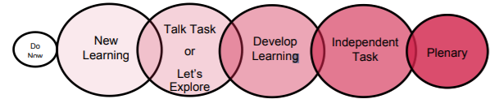
Each Mathematics Mastery lesson, from R – Y6, is provided in a six-part lesson structure. The Dimensions of Depth under pin the six-part lesson. Each part provides opportunities to focus on conceptual understanding, language and communication and mathematical thinking for the mathematical concept being covered.

Do Now: This is a quick five-minute task that all pupils can access without any teacher input as an introduction to the mathematics lesson.

New Learning: The New Learning segment introduces the lesson’s main
Mathematical concepts.

Talk Task or Let’s Explore: The Talk Task or Let’s Explore is a chance for all pupils to practise using mathematical vocabulary related to the lesson’s concept.
Develop Learning: This segment builds on the New Learning and develops a deeper understanding of the maths concepts of that lesson. It also addresses misconceptions or inaccuracies discovered during the preceding segment.

Independent Task: The Independent Task provides pupils with the opportunity to practise the learning from that lesson. This may be independently and/or in pairs/small groups.

Plenary: The Plenary segment recaps on the lesson, checking understanding and celebrating success.

