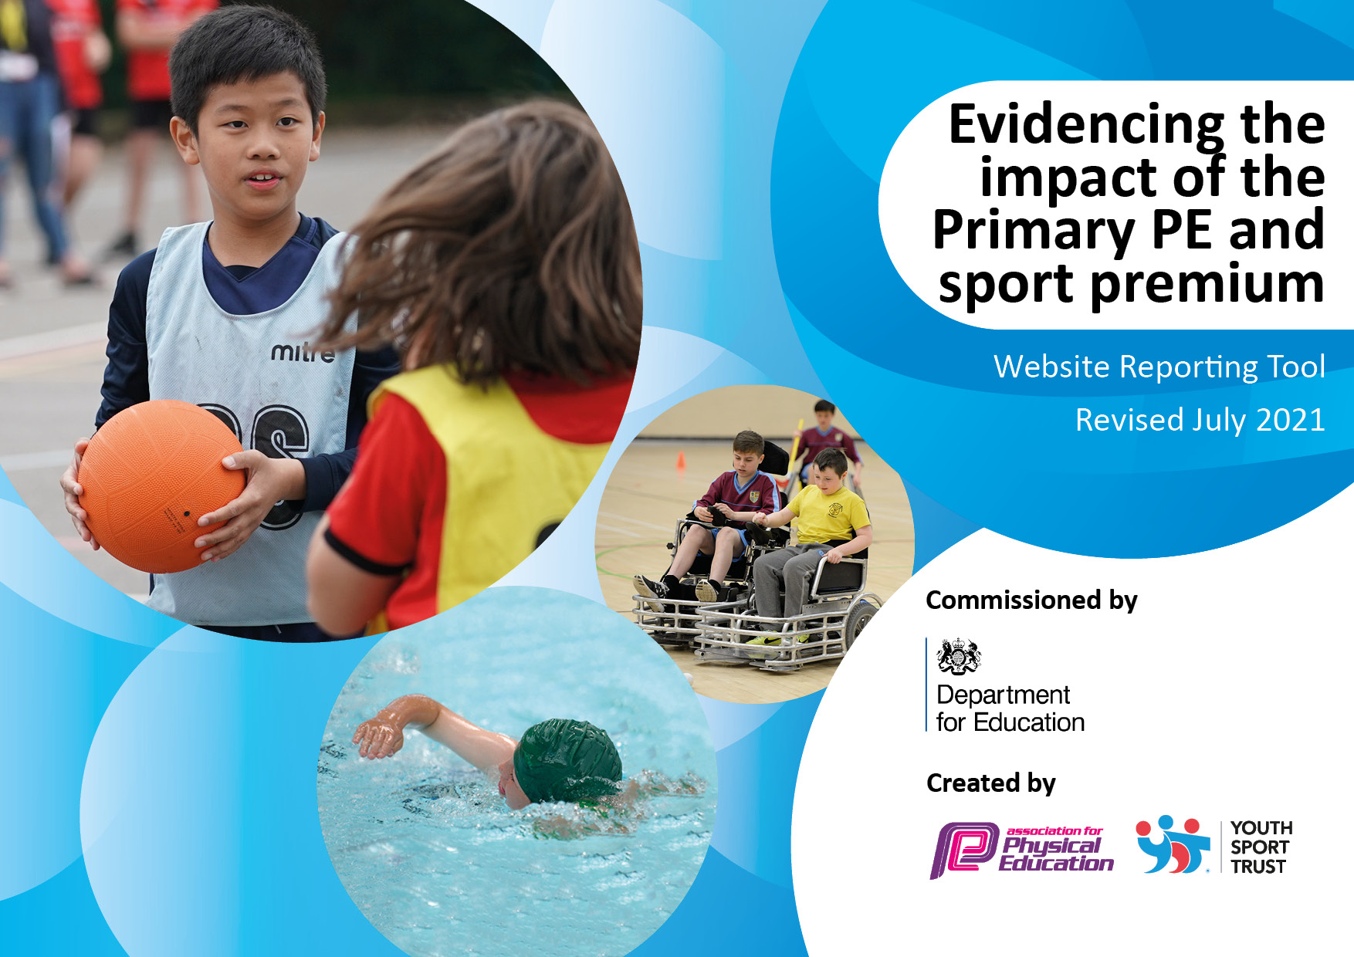
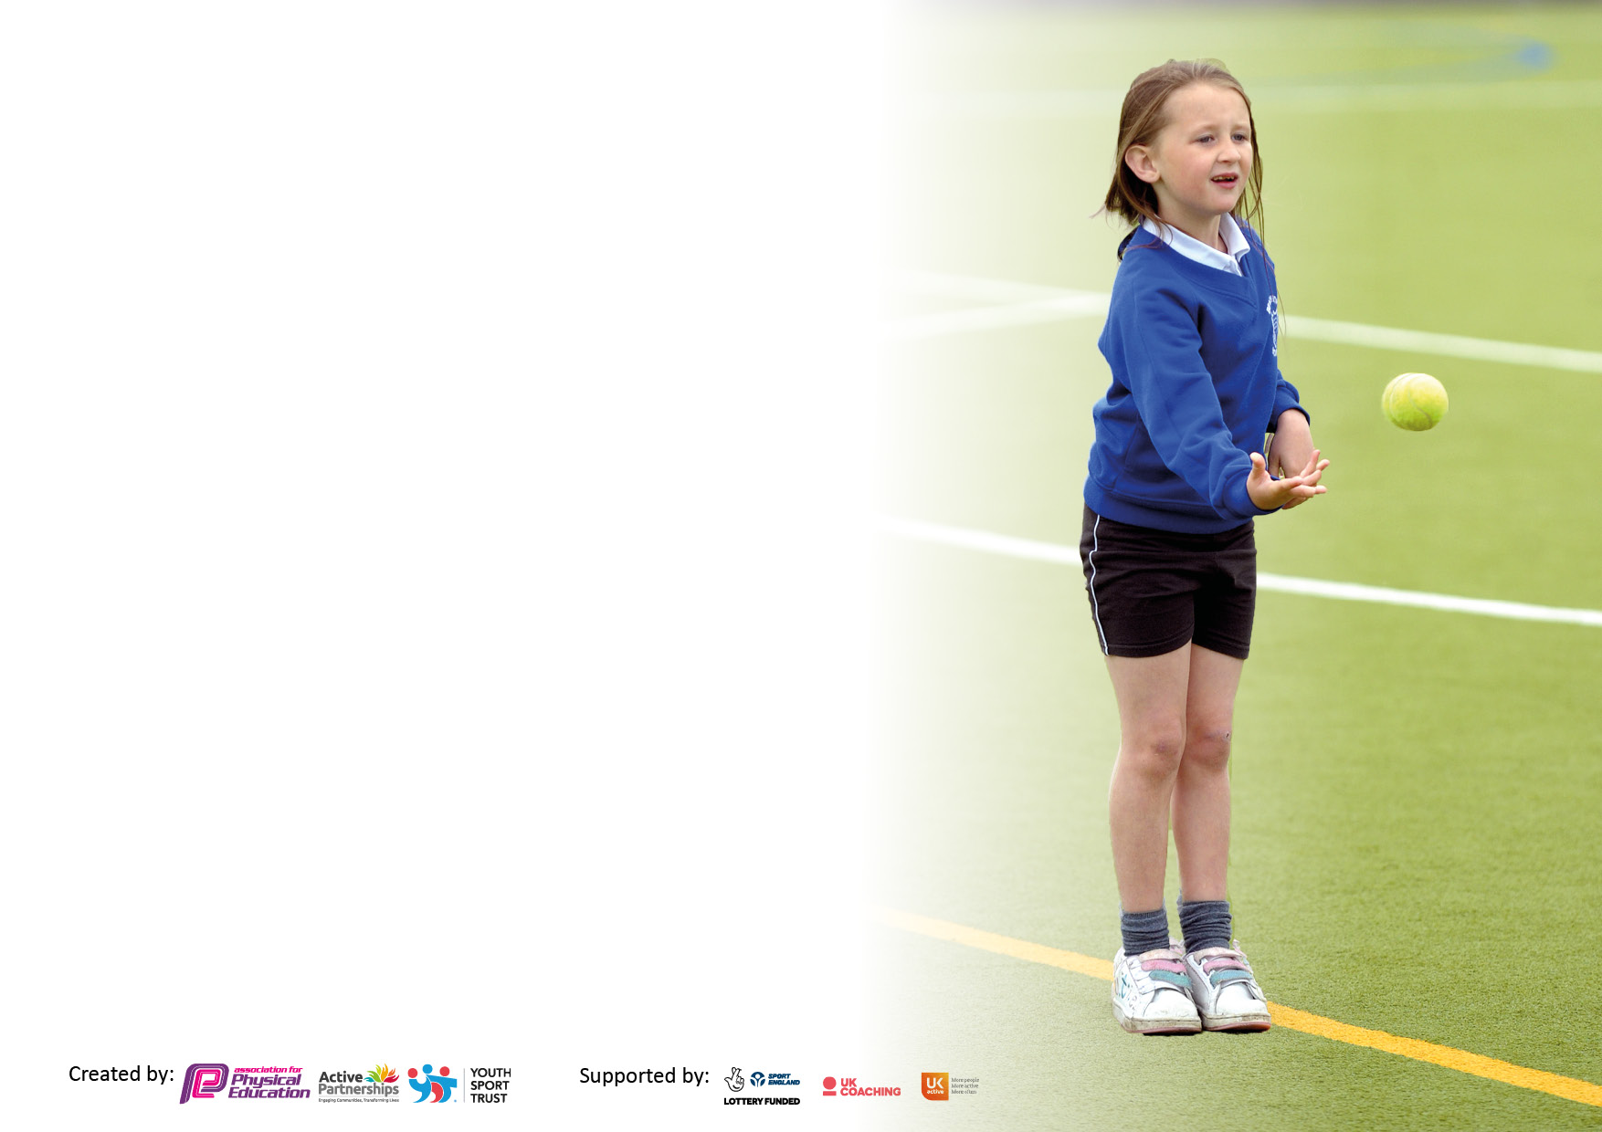

It is important that your grant is used effectively and based on school need. The Education Inspection Framework makes clear there will be a focus on ‘whether leaders and those responsible for governors all understand their respective roles and perform these in a way that enhances the effectiveness of the school’.

Under the Quality of Education Ofsted inspectors consider:
Intent - Curriculum design, coverage and appropriateness
Implementation - Curriculum delivery, Teaching (pedagogy) and Assessment
Impact - Attainment and progress

To assist schools with common transferable language this template has been developed to utilise the same three headings which should make your plans easily transferable between working documents.

Schools must use the funding to make additional and sustainable improvements to the quality of Physical Education, School Sport and Physical Activity (PESSPA) they offer. This means that you should use the Primary PE and sport premium to:

- Develop or add to the PESSPA activities that your school already offer
- Build capacity and capability within the school to ensure that improvements made now will benefit pupils joining the school in future years
- The Primary PE and sport premium should not be used to fund capital spend projects; the school’s budget should fund these.

Pleasevisitgov.ukfortherevisedDfEguidanceincludingthe5keyindicatorsacrosswhichschoolsshoulddemonstrate animprovement.Thisdocumentwillhelpyoutoreviewyourprovisionandtoreportyourspend.DfEencouragesschools to use this template as an effective way of meeting the reporting requirements of the Primary PE and sport premium.

We recommend you start by reflecting on the impact of current provision and reviewing the previous spend.

Schools are required to publish details of how they spend this funding, including any under-spend from 2019/2020, as well as on the impact it has on pupils’ PE and sport participation and attainment. All funding must be spent by 31st July 2022.

We recommend regularly updating the table and publishing it on your website throughout the year. This evidences your ongoing self-evaluation of how you are using the funding to secure maximum, sustainable impact. Final copy must be posted on your website by the end of the academic year and no later than the 31st July 2021. To see an example of how to complete the table please click HERE.

Details with regard to funding
Please complete the table below.

Total amount carried over from 2019/20 | £n/a
Total amount allocated for 2020/21 | £18040
How much (if any) do you intend to carry over from this total fund into 2021/22? | £5,400
Total amount allocated for 2021/22 | £17480 + £5,400
Total amount of funding for 2021/22. To be spent and reported on by 31st July 2022. | Estimated spend: £22,880 (fluctuations will increase due to further amount of release time/subsidised sporting trips)
Swimming Data
Please report on your Swimming Data below.

Meeting national curriculum requirements for swimming and water safety.  N.B. Complete this section to your best ability. For example you might have practised safe self-rescue techniques on dry land which you can then transfer to the pool when school swimming restarts.  Due to exceptional circumstances priority should be given to ensuring that pupils can perform safe self rescue even if they do not fully meet the first two requirements of the NC programme of study | Based on figures when children were last able to attend swimming, impacted due to Covid’19
What percentage of your current Year 6 cohort swim competently, confidently and proficiently over a distance of at least 25 metres?  N.B. Even though your pupils may swim in another year please report on their attainment on leaving primary school at the end of the summer term 2020.  Please see note above | Began swimming with Y4 in 2018/19 57% achieved 25m standard
What percentage of your current Year 6 cohort use a range of strokes effectively [for example, front crawl, backstroke and breaststroke]?  Please see note above | Began swimming with Y4 in 2018/19 69% could use a range of stroke effectively
What percentage of your current Year 6 cohort perform safe self-rescue in different water-based situations? | Began swimming with Y4 in 2018/19 67% could self-rescue
Schools can choose to use the Primary PE and sport premium to provide additional provision for swimming but this must be for activity over and above the national curriculum requirements. Have you used it in this way? | Yes/No

Action Plan and Budget Tracking
Capture your intended annual spend against the 5 key indicators. Clarify the success criteria and evidence of impact that you intend to measure to evaluate for pupils today and for the future.

Academic Year: 2020/21 | Total fund allocated: £22,800 | Date Updated: September 2021
Key indicator 1: The engagement of all pupils in regular physical activity – Chief Medical Officers guidelines recommend that primary school pupils undertake at least 30 minutes of physical activity a day in school |  |  |  | Percentage of total allocation:
 |  |  |  | 53%
Intent | Implementation |  | Impact
Your school focus should be clear what you want the pupils to know and be able to do and about  what they need to learn and to  consolidate through practice: | Make sure your actions to achieve are linked to your intentions: | Funding allocated: | Evidence of impact: what do pupils now know and what can they now do? What has changed?: | Sustainability and suggested next steps:
Ensure resources are well stocked to promote sporting and active activities at break and lunch times, including new storage equipment.  Swimstars  Ensure a wide variety of skills and activities are taught to increase the percentage of pupils in meeting the national curriculum expectation for swimming and water safety.  QFT approaches to PE are continued to be embedded across the academy to ensure teaching of PE is rated ‘good’ by Summer 2022.  Pupils are engaged in physical activity over lunch time, behaviour incidents will be reduced.  Re-launch of whole school daily movement break ’Daily Mile’ to ensure all pupils are undertaking at least 15 minutes’ additional activity per day.  Access to high quality clubs and programmes to help young people reach sufficient levels of physical activity. | -PE lead to audit resources and purchase new resources tailored for all key stages, before the beginning of each new half term topic.  - PE Lead to decide on storage facilities for equipment.  - PE Lead to facilitate CPD with staff to incorporate structured play activities.  PE lead to track the percentage of pupils on track to meet the national curriculum expectation for swimming and water safety including badges awarded who missed opportunity due to Covid 19.  PE Lead/VP to support ECT in planning and delivery of Real PE.  Termly monitoring of PE including drop ins with Principal/Vice Principal/PE Lead and provide tailored support where developments arise.  CPD sessions for all staff incorporated (TAs, Lunch time Supervisors and Teachers) around positive, structured play and behaviour management, provided by BOSS and other outside agency.  Tracking and benchmarking to monitor the progression of pupils.  Further CPD opportunities scheduled this year around QFT and sporting including Positive Play, Behaviour Management and Assessment for Learning.  Extra lunch time assistant appointed to ensure clubs can take place.  Planning and resourcing of whole school movement break to ensure consistent approach across the academy, including shared time across the academy and marked track.  Monitoring of implementation and providing further support to key staff.  PE lead to liaise with staff to ensure after school club offer is to a high quality.  Gather pupil voice of uptake and interest.  Establish sporting after school clubs run by class teachers.  PE Lead to track attendance and monitor effectiveness of resource.  Analysis of key category groups PP/SEND/Boys/Girls and feedback to Principal/VP. | Approx. £4000- Sheds  £1000-Resourcing  Cover (1/2 day per term) £90x3=270  Total- £5270  Coach and lessons Y5- £2000  Cover- (3 day  PE lead £180x 3=£540  VP= £250x3= £750)  Total =£1290*  CPD =£1000  Total-£2290  £2,543  Cover- (1/2 day PE lead x3) £90 per half day  Total- £270  Cover  PE Lead- 3x£180-£540)  Total= £540  Teacher Release (6 sessions) £94.62x 6  Total-£1,107.72 | Participation levels have risen at play times. Behaviour incidents have lowered and children demonstrate wider variety of knowledge of games through adult support.  Targeted year 5 children that had incomplete lessons during 2019/2020. Lessons booked from February onwards. If space available will then target children that did not gain 25m competent swimming.  Teaching sequence is in place for all teachers to follow when delivering P.E. P.E lead has created knowledge organisers for all teachers to adhere to before teaching the unit. All of the above has ensured that children are making expected progress and being active for sustained periods of time. P.E lead has undertaken subject leader training to support creating the curriculum. Learning walks demonstrate knowledge and understanding has improved in P.E of relevant skills and outcomes. Teaching and Learning maximises pupil participation and progress throughout the lesson  Behaviour incidents have decreased.  .  Assessment of long term outcomes is in place, teachers assess the progression of their pupils termly.  New lunch time assistant appointed.  Children are moving more through the day instead of being sedentary and understand why they do physical activity everyday to improve their mental and physical wellbeing. The daily mile is a non-negotiable and is timetabled in to everyone’s timetable.  Club data evidences increased offer and participation. Parent and pupil voice was collected in Spring to see what next steps were for Summer. Class teachers have taught 2 clubs throughout the year each. Analysis of PP/SEN/Boys/Girls showed numbers were low for SEN so we ensured we gathered their voice in what clubs they would like to do and we have seen an increase.  Club links have been contacted and given children taster sessions for all year groups. | Next steps: Observation of girls and boys activity levels on the playground and be conscious of what is happening on the playground to assess the impact of participation. Further evidence to be gathered through pupil voice.  Track swimming data and target children to meet NC requirements. Continue to track data and allocate funding accordingly  Further evidence to be gathered through pupil voice. Continue to share good practise.  P.E lead to collect data moving forward to see how P.E curriculum could be mapped.  Increase number of sporting opportunities for more than one class to play ‘football’ at playtimes.  Target children with low fitness levels. Continue to embed into curriculum offer.  Offer support for inexperienced staff with planning resources.  Continue to analyse and increase participation levels in PP/SEND/Boys/Girls  Continue to make other club links to create a variety of sporting choices.
Key indicator 2: The profile of PESSPA being raised across the school as a tool for whole school improvement |  |  |  | Percentage of total allocation:
 |  |  |  | 5.6%
Intent | Implementation |  | Impact
Your school focus should be clear what you want the pupils to know and be able to do and about  what they need to learn and to  consolidate through practice: | Make sure your actions to achieve are linked to your intentions: | Funding allocated: | Evidence of impact: what do pupils now know and what can they now do? What has changed?: | Sustainability and suggested next steps:
Continue to build on communication of celebrating sporting achievements. Prominently in school in school to inspire and motivate  Continue to ensure social media promotes sports and the offer for sport at Waverley so pupils and parents are aware of opportunities.  QFT approaches to PE are embedded across the academy to ensure teaching of PE is rated ‘good’ by Summer 2022.  The PE coordinator will continue to monitor and evaluate the delivery of Real PE to ensure it is of a high quality across school. | Ensure School Environment demonstrates the celebration of sporting achievements including trophy display cabinet.  PE lead to organize an assembly at the end of each term to celebrate pupils’ sporting achievements  - Achievement in sport are lined up with school’s core value strategy- resilience, aspiration, contribution, happiness  Maintain social media accounts.  Tweet about sports, competitions, PE lessons and sports in the community.  PE Lead/VP to support ECT in planning and delivery of Real PE.  Termly monitoring of PE including drop ins with Principal/Vice Principal/PE Lead and provide tailored support where developments arise.  CPD sessions for all staff incorporated (TAs, Lunch time Supervisors and Teachers) around positive, structured play and behaviour management, provided by BOSS and other outside agency.  Tracking and benchmarking to monitor the progression of pupils.  Further CPD opportunities scheduled this year around QFT and sporting including Positive Play, Behaviour Management and Assessment for Learning. | £0  Possible cost of new display cabinet.  £0  Cover  (3 x 1 day =  VP 3x £250-£750  PE Lead- 3x£180-£540)  Total= £1,290 | Children feel proud to see their sporting achievements being recognised. Photos of children taking part in out of school activities has inspired others to join school clubs or out of school clubs. Children are encouraged to bring in sporting awards into school to share. Children have been selected for Astrea Active Awards across the Trust. Assemblies have been delivered by current professionals to communicate elite pathways.  Children and parents know local club links that are shared via newsletters and social media accounts.  See KP1. | Continue to promote and display PE, competition and physical activity.  Continue to work with professionals to give children pathways for elite performance.  Continue to share club links.

Key indicator 3: Increased confidence, knowledge and skills of all staff in teaching PE and sport |  |  |  | Percentage of total allocation:
 |  |  |  | 17.7%
Intent | Implementation |  | Impact
Your school focus should be clear | Make sure your actions to | Funding | Evidence of impact: what do | Sustainability and suggested
what you want the pupils to know | achieve are linked to your | allocated: | pupils now know and what | next steps:
and be able to do and about | intentions: |  | can they now do? What has
what they need to learn and to |  |  | changed?:
consolidate through practice:
Continuation of the development of new PE lead to build on subject knowledge and share best practice from other leads across and beyond the trust  Monitoring of Real PE in order to improve progress and achievements of all pupils and focus on upskilling of staff.  -Planning will support teachers to build on the relevant skills needed to play and take part in sports both competitive and non-competitive.  Totally Runnable- Silver Package  Addressing the gender gap in PE attainment and staff knowledge. | PE lead to be released for termly Astrea Active conferences  - Host inter-house competitions  -Develop skills of the leader to  evaluate impact of PE provision.  PE leader to monitor the impact of new PE scheme with support of Principal and Vice Principal including planning and delivery of PE sessions.  - PE lead to work with Principal and Vice Principal to provide further CPD for staff.  - All practice judged ‘good’ by Summer 2022.  Totally Runnable Girl on the Run 6-week course – allocate a female teacher to attend all sessions as a role model  Access to Totally Runable CPD for PE coordinator and specific training available for other teaching staff.  -Pupils to have access to in-school sessions around ‘Closing the Gender Gap’  -Through working with the specialist coaches, staff will clearly see the progression of skill development and the structure and sequence that lessons should follow.  -Higher standards in PE lessons throughout school.  -All staff to be confident and competent to use a range of learning styles in PE | Cover- (1x 3 days  £180x 3=£540  Cover (PE lead 1x 3 days  £180x 3=£540  VP=3X£250=£750)  Total=£1,290*  £3500 | Children have competed in Intra competitions to compete in Inter-house competitions across the trust each term.  Teaching and learning demonstrates improved knowledge and understanding. P.E lead has delivered CPD and set expectations of a ‘good’ PE lesson.  P.E observations have been undertaken to support ECTs with planning. Knowledge organisers have been created for staff to ensure staff know the prior leaning and key vocabulary.  Female member attended all sessions to support the girls in their run.  Confidence ratings from y5 girls shows a significant difference from before the support from totally runnable to now. Children join in with P.E and want to attend after school clubs and join in with competitions.  Progression on skills document has supported teachers in knowing the progressions of skills in that unit. Children are moving on with their learning in lesson and no time is lost. | Continue to work with the trust to build on subject knowledge on pedagogy. Continue to share best practise with other trusts.  Ensure clubs are mapped out on the LTP and teams have time to practise before any event.  Staff confidence has improved and are able to deliver units independently to a good quality.  To continue with the work they have done this year with totally runnable and develop ‘Sport ambassadors’ with the support from Totally Runnable.  Continue to work on ‘teacher toolkit’ in staff meetings.
Key indicator 4: Broader experience of a range of sports and activities offered to all pupils |  |  |  | Percentage of total allocation:
 |  |  |  | 13%
Intent | Implementation |  | Impact
Your school focus should be clear | Make sure your actions to | Funding | Evidence of impact: what do | Sustainability and suggested
what you want the pupils to know | achieve are linked to your | allocated: | pupils now know and what | next steps:
and be able to do and about | intentions: |  | can they now do? What has
what they need to learn and to |  |  | changed?:
consolidate through practice:
After School Clubs and sport sessions provided by teaching staff.  Subsidised visits to professional sports fixtures to broaden children’s experiences of sports: this will ensure that children get opportunity to experience a wider range of professional sports events. | After School Club involves active lifestyle events to raise profile of sports and active lifestyles.  Sporting trips as outlined in Astrea Promise booklet  PE lead(s) and SLT to map out Astrea Promise and sporting trips.  PE lead(s) to organise school team to visit EIS for inter-school competitions. | Cover  (3 x 1 day =  VP 3x £250-£750  PE Lead- 3x£180-£540)  Total= £1,290  Teacher Release (6 sessions) £94.62x 6  Total-£1,857.72  Costed above*  Coach x 6 per year group £3000  Total- £3000 | All new clubs started in Autumn 1 using the new equipment purchased.  All sporting trips outlined in Astrea Promise booklet have been completed.  Intra cross country and cricket competition completed.  Inter Tri Golf, Cricket and Athletics gone ahead. | Continue to develop and evaluate sport and physical activity offer to children and participation levels to ensure improved participation levels of all groups of children.  Ensure School Games Mark is GOLD next year.  Continue to track number of competitions offered and criteria for School Games Marks in order to build on provision and what is offered.

Key indicator 5: Increased participation in competitive sport |  |  |  | Percentage of total allocation:
 |  |  |  | 10%
Intent | Implementation |  | Impact
Your school focus should be clear | Make sure your actions to | Funding | Evidence of impact: what do | Sustainability and suggested
what you want the pupils to know | achieve are linked to your | allocated: | pupils now know and what | next steps:
and be able to do and about | intentions: |  | can they now do? What has
what they need to learn and to |  |  | changed?:
consolidate through practice:
Inter school and intra school competitions to introduce children to the competitive side of sports and the etiquette which comes with it.  Hold annual sports days so that all pupils have opportunity to compete against their peers | PE lead to monitor participation in football and mutli-skill activities.  -Widen opportunities across the Doncaster hub in 21/22 (once per half term and once government guidance allows)  -Continue to use venues such as EIS/Doncaster Rovers to broaden children’s outlook on sport and physical activity.  PE Lead to plan and organize Sports Day including different sporting activities, Teams, prizes and parental involvement.  PE Lead to track and places won in sports day and filter into categories PP/SEND/Boys/Girls/EAL  Feedback to Principal and Vice Principal for future planning and targeted groups to promote sport. | Coach per trip £250 x6  Cover (3 day + PE Co) £180x3=£540  £2040 (may fluctuate due to number of intra competitions  Cover (2 day +PE Co) £180x2=£360 | Intra cross country and cricket competition completed.  Inter Tri Golf, Cricket and Athletics gone ahead.  Children have worked hard on fair play. Children know the feeling of winning and losing and know how to manage their emotions and be proud of others for their success’.  KS1 and KS2 sports day completed. | Work with SGO to attend other trust competitions.  Continue to track number of competitions attended.  Target least active children.  Gather pupil and parent voice to make improvements for next year.

Signed off by
Head Teacher: | L.stanton
Date: | 03.10.2021
Subject Leader: | B.Wright
Date: | 30.6.22
Governor:
Date:

