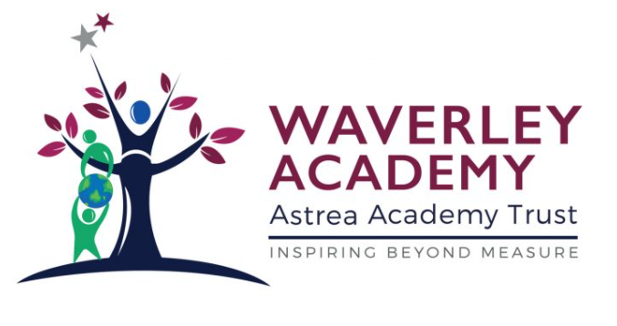Our School Values/ Assembly Themes/ Visitors throughout the Year

Month | Values/ Learner Traits we are focusing on | Festivals/ Events taking place | Visitors coming into assembly
September | The Waverley Learner Profile  Being Brilliant  Core Value- Tenacity | Welcoming new pupils to the school  Reviewing our school rules  Appointing Learning Ambassadors
October |  | Black History Month  6th October – Mental Health Day Assembly
November | Core Value- Empathy | 1st November Bonfire Night- Fire work Safety Assembly  11th- - Remembrance Assembly  15th- Anti bullying Assembly
December |  | 1ST –Advent Assembly  6th- Hannukah Assembly  13th- Christmas Assembly
January | Core Value-Curiosity | 3RD- Welcome Back assembly- Learning Ambassadors  10TH- Online Safety assembly PM with Shaun Kessell  17th- Core Value- Curiosity Assembly  19th- Red January Launch Assembly  24th- Tolerance- Holocaust Memorial Day Assembly  26th- Pause for Thought- Who should we copy? Assembly  31st- Safer Internet revisited Assembly | 10TH- Online Safety assembly PM with Shaun Kessell
February |  | 2nd- Planet Protectors Assembly  7th- Chinese New Year Assembly with Mr Chappell  9th- Opportunity Knocks Assembly  21st- Fair Trade Assembly  23rd- Pause for thought! Who will I become Assembly  28th- World Book Day Launch | 7th- Chinese New Year Assembly with Mr Chappell
March | Core Value-Scholarship | Women’s History Month  1st March – Shrove Tuesday  1st March - St David’s Day  You’ve got a friend in me. What it means to be a good friend Assembly  3rd March – World Book Day -  7th March – International Women’s Day- Valiant Women (celebrate a key figure through history) Assembly  14th- Respecting Others Assembly  9th March – Science Week  17th March - St Patricks Day  19th March – Holi (Hindu)  21st March – Keeping Safe- Road Safety-Shaun Kessell Assembly  27th March – Mother’s Day  28th- What does Easter mean? Assembly | 21st March – Keeping Safe- Road Safety-Shaun Kessell
April |  | 19th- Autism Awareness Assembly-SENCO  20TH- Ramadan Assembly  25th- St George’s Day Assembly  27th- Earth Day assembly- Geography Lead
May | Core Value- Happiness | 2nd May - Eid  10th May – SATs Week  23rd May – Creative Arts Week – Arts Lead
June |  | 5th June – World Environment Day – Geography Lead  6th June – Anniversary of D-Day – History Lead  19th June – Father’s Day  20th June – World Refugee Day – PSHE Lead
July | Reflection/ Achievement / Looking ahead | Transition to new classes  Celebration

